Multithreading in Java

Yinsheng Dong(yid164) Hao Li(hal356) Ruida Xie(rux793)

Abstract: Multithreading in Java is multiple threads can be executed simultaneously in one process, and it is a Java feature for maximum utilization of CPU to achieve multitasking. This approach is widely used in games, animation, web programming, etc. Programmers use multithreading in Java commonly because of memory saving and time-consuming. Threads not only can share a shared memory so that programmers do not need to allocate separate memory area, but also context-switching from one thread to other one is faster than other approaches (multiprocessing). In this paper, we present a brief analysis about Multithreading in Java including definition, example, advantages and disadvantages about Multithreading in Java.

- Introduction

Threads are the smallest unit of processing. They execute in the path separately. Threads in a process are independent, so one thread will not be able to affect another. They are formed like [Figure 1]. A memory address can be shared by multiple threads, and threads can make the runtime environment asynchronous, so different tasks can be executed in same time. Java provides an object “java.lang.Thread” which represents and controls threads.
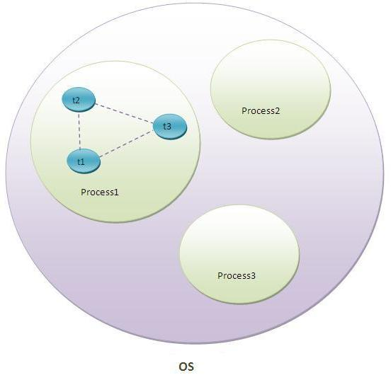

Figure 1 Threads in Process
Multithreading is one of the approaches to achieve Multitasking. Multitasking is the ability to perform more than one activities concurrently on a computer. Multitasking is achieved by Process-based Multitasking (Multiprocessing) and Thread-based Multitasking (Multithreading).

Multiprocessing makes processes to run concurrently on a computer. It allows every process has its memory space, so programmers need to allocate separate memory areas for each process that they defined. The process is heavyweight, so the communication between processes is high cost. Otherwise, the switching from one process to another requires some time for saving and loading registers, memory maps, updating list, etc. An example is while a person is visiting a website by Chrome, he is using a player to listen to music.

Multithread gives a different way to solve multitasking. It allows different parts of the same process to run concurrently, so threads share the same address space. For example, printing and formatting text in a word processor at the same time. Because the thread is lightweight, the cost of communication between the thread is less expensive than Multiprocessing.

The first reason for using Multithreading in Java is programmers can make user tasks run at the same time. For example, in a Java GUI application, developers can use Swing and Java FX to achieve multithreading. In [Figure 2], when a user press Start button, the application starts a task, and this task would take some time to complete. If the GUI frozen, it gives user a bad experience. In this application, programmers separated threads to carry out the time-consuming task and keep showing a relevant message to the user, and it gives a better experience to users.
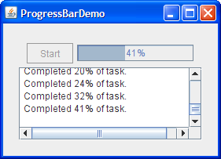

Figure 2 Multithread for GUI
The second reason is Multithreading in Java can improve CPU power. For instance, A CPU has four cores like [Figure 3], but you only use one of the cores for serving clients. In this situation, programmers can use all threads to serve clients which maximizes throughput to 4 times, so the CPU has been utilized.
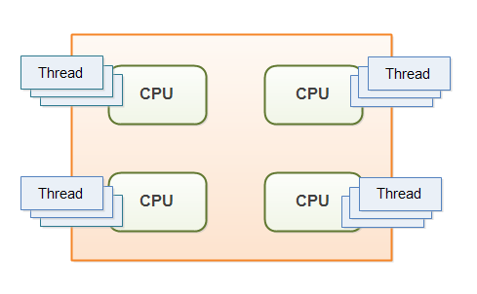

Figure 3 Multithread in CPU

The third reason is Java programmers can use multithreading approach to reduce response time by diving a big submit task into multiple subtasks, and one of the subtasks could be sunk into numerous lower level subtasks because Java provides Fork/Join thread pool for just that purpose [Figure 4].
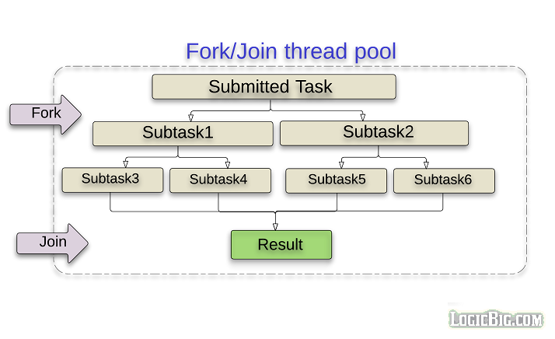

Figure 4 Fork-Join thread pool

Then, using Multithreading can also serve multiple clients at the same time. If an application produced by using one thread, it can only serve only one client, but a multi-threaded server [Figure 5] can connect with multiple clients at same time. This means the next client does not need to wait until current client finish request. It improves the efficiency of the server.

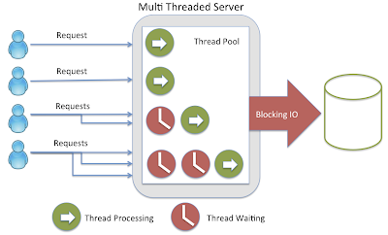

Figure 5 Multithread serve clients
In this paper, we present a simple tutorial about Multithreading in Java. The second section presents thread life cycle and thread scheduler in Java. We show the simple implementation of Java multithread in the third section, and the fourth section presents limitation and possible solutions of Multithread in Java. The final section concludes the paper.

- Thread Life Cycle and the Thread Scheduler in Java

In Java, the life cycle of the thread is controlled by JVM. There are six states in thread life cycle which are “New”, “Runnable”, “Blocked”, “Waiting”, “Time waiting” and “Terminated”, [Figure 6] presents states of a thread at any instant of time. We often use Thread.getState() method to get the current state of the thread.
- New state: It is in the new state when a new thread is created. The thread has not yet started to run before invoking the start() method.
- Runnable State: A thread that is ready to run after invoking the start() method. In this state, a thread might be running or it might be ready run at any instant of time
- Blocked/Waiting state: the thread is still alive, but it is not able to run currently. When a thread is temporarily inactive, then it's in Blocked state or Waiting state.
- Timed Waiting state: the thread is waiting for timeout notification.
- Terminated State: A thread terminates or dead state when its run() method exits. It occurs when the program has fully executed or when some unexpected events happened, such as an unhandled exception or power cut.

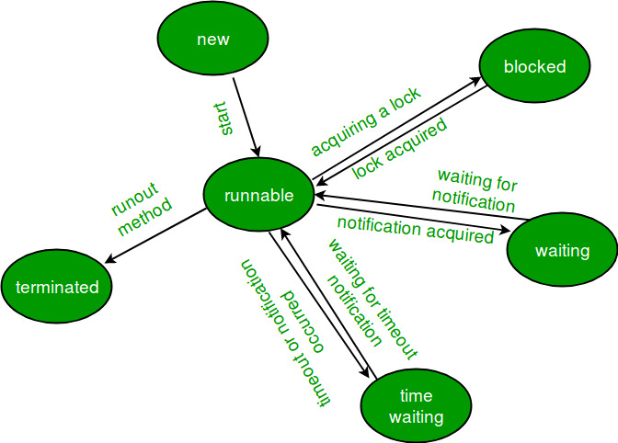

Figure 6 Thread States

Thread scheduler helps different states to make decisions. Firstly, the thread scheduler is giving the thread time to run in the Runnable state. Usually, A multi-thread program allocates a fixed amount of time to execute every thread, and the thread scheduler helps to allocate time for every thread. Secondly, Block/Waiting state is also controlled by the thread scheduler. For example, when two threads try to access a protected section of code that is currently used by other thread, these threads are in Block state. When the section is unlocked, the thread scheduler will pick one thread to make it runnable, and another one which also tries to access this section will be in Waiting state. The thread scheduler moves the waiting thread to runnable state after it receives the runnable notification. Furthermore, the thread scheduler can schedule a thread in the runnable state to run even if a currently running thread is moved to Blocked/Waiting state. Finally, Time waiting state occurs when a thread calls a method with the timeout parameter. In this state, the thread needs to wait until the timeout is completed or the thread scheduler receives the notification. For example, a thread will be moved to waiting state when it calls sleep or conditional wait.

- Simple Implementation of Java Multithread

There are two ways to implement multithreading in Java: Inherit the Thread class and implement the Runnable interface. In software engineering, implementing the Runnable interface is the most popular way.

[Figure 7] is inheriting the Thread class:

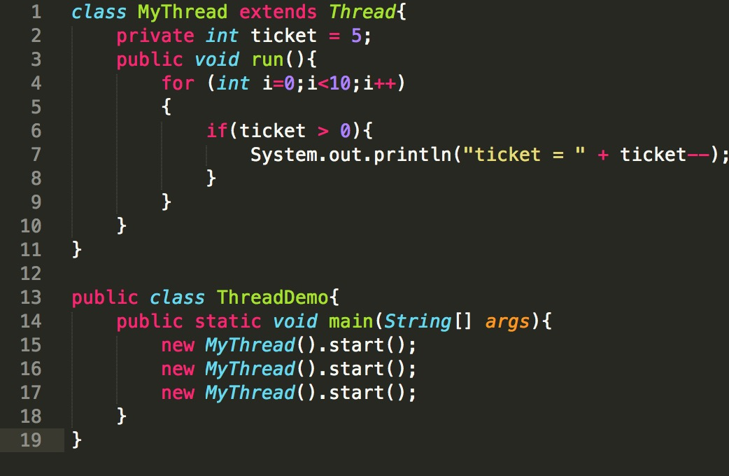

Figure 7 Inheriting the Thread Class

In [Figure 7], each thread alone sold five tickets, i.e. each thread completes the task independently. However, in practical applications, such as train station ticket, the program needs to work with multiple threads to complete one task, in this case, multiple threads work together to buy five tickets in total.

[Figure 8] is implementing the Runnable interface.
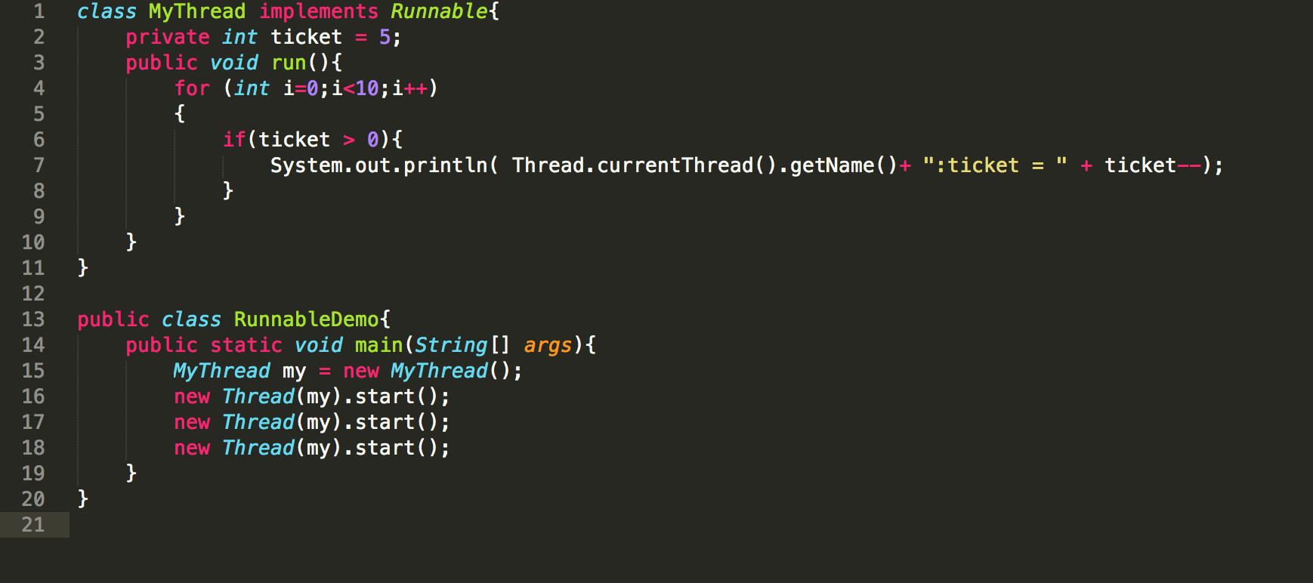

Figure 8 Implementing Runnable interface

[Figure 8] presents three threads sold five tickets in total, that is, they completed the task of buying tickets together.

In [Figure 7], we created 3 Thread objects. Three threads execute the code in each of the three objects; in the second example, we also created 3 Thread objects, but only one Runnable object, 3 Thread objects is sharing resources in this Runnable object. Therefore, there will be three threads together to complete the ticketing task. If we created 3 Runnable objects, as the parameters were passed into three Thread objects, then three threads will be independent of their respective Runnable object code. In that case, three threads each sell five tickets.

In [Figure 8], the three Thread objects co-execute the code in a Runnable object, which may cause the thread to be unsafe, for example, the ticket may output -1 (if our System.out .... statement is preceded by thread sleeping operation, the situation could appear). This situation is due to a thread determine ticket is 1> 0, have not had time minus 1, another thread has the ticket minus 1, into 0, then the next thread before the ticket minus 1, they got -1. This requires the addition of synchronous operations, ensuring that only one thread is executing each for loop at a time. In the first example, we do not need to add the synchronization operation, because each thread to execute its code in the Thread object.

When a thread is running, another thread can interrupt() it by calling the interrupt() method of the corresponding Thread object. The method merely sets a flag in the target thread to indicate that it has been interrupted and returns immediately. It should be noted here that, if only a simple call interrupt () method, the thread is not interrupted, will continue to implement. The following figure shows interrupt of the sleeping thread.

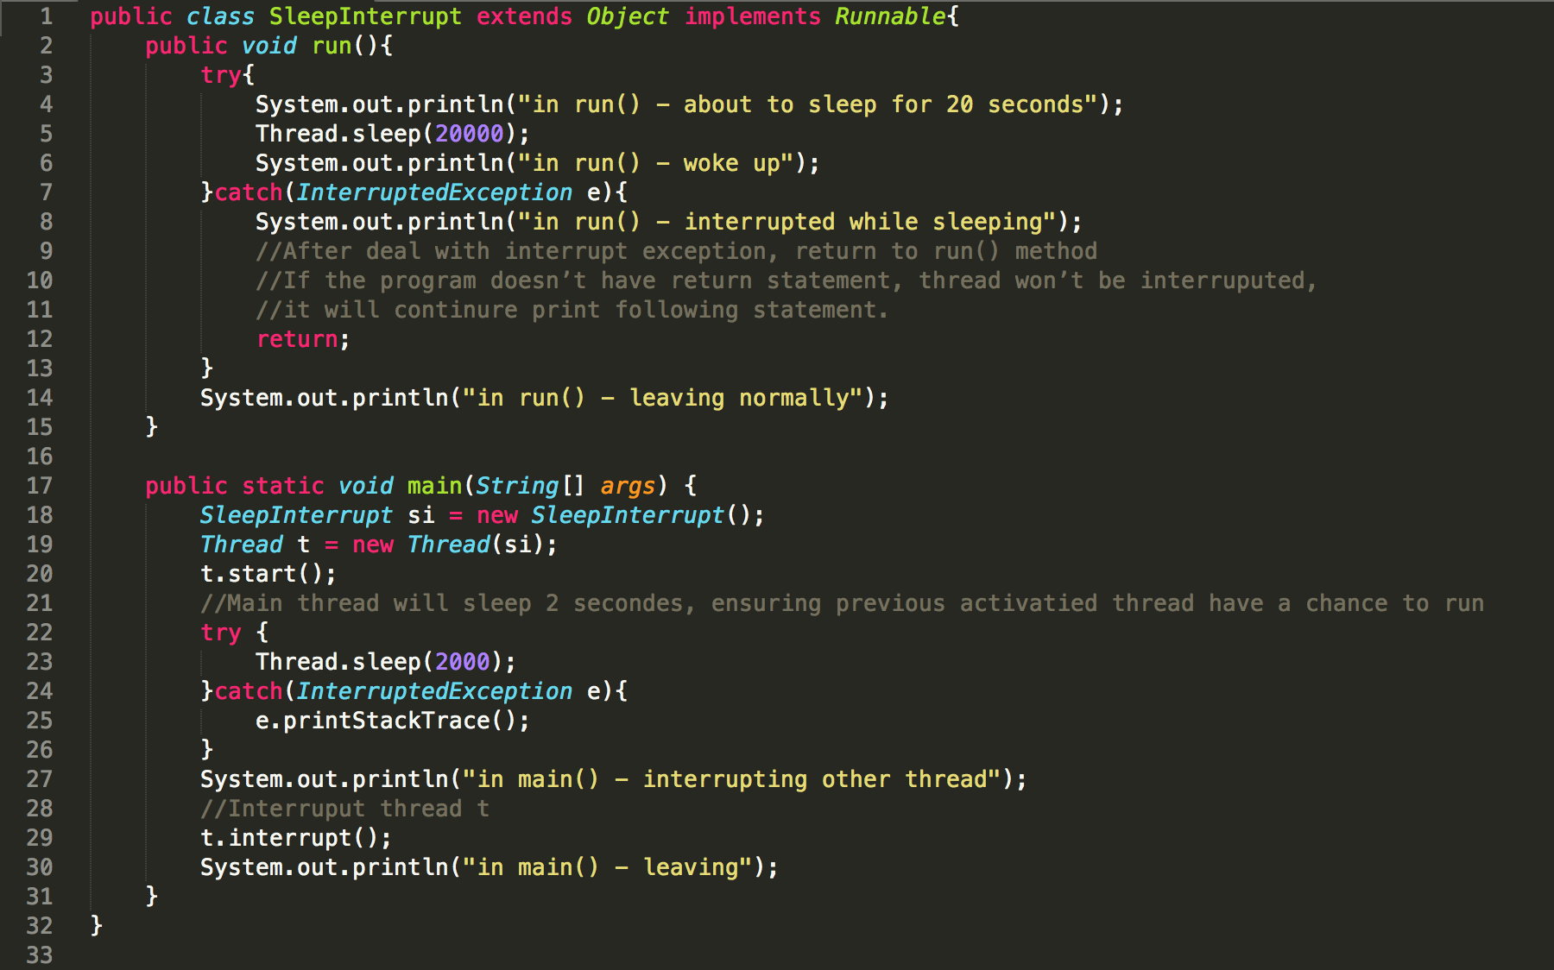

Figure 9 Thread Interruption

After the main thread starts a new thread, it sleeps for 2 seconds such as [Figure 9], allowing the new thread to get up-time. After the new thread print "about to sleep for 20 seconds" it will sleep for 20 seconds. After about 2 seconds, the main thread notifies the new thread of the interruption, and the 20 seconds of sleeping of the new thread will be interrupted, thus throwing an InterruptException. The execution jumps to the catch block, and prints out the "interrupted while sleeping" message, and immediately return from the run() method, and dies, without printing the "leaving normally" message behind the catch block.

Also, if the return statement in the catch block is commented out, the thread will continue to execute after it throws an exception, without being interrupted, leaving a "leaving normally" message printed.

In concurrent programming, the resources accessed by multiple threads concurrently are called critical resources. When multiple threads simultaneously access objects and request the same resources, the operation may cause data inconsistency or incomplete data. To avoid this case, we will take a synchronization mechanism to ensure that only one thread is allowed in the method at a time. Synchronization mechanism using synchronized modifier is called mutex mechanism, which is called a lock named mutex. Each object has a monitor (lock tag), when the thread has this lock tag can access this resource. Otherwise the thread will enter the lock pool. Any object system will create a mutex for it; the lock is assigned to the thread to prevent the interruption of atomic operations. The lock of each object can only be assigned to a thread, so-called mutex.

Each instance of a class has its object-level lock. When a thread accesses synchronized code block or synchronized method in an instance object, the thread gets the object-level lock of the instance. Other threads need to wait for blocking if they want to access this synchronized code block or synchronized method at this time. The previous thread exited from the synchronized code block or method, releasing the object-level lock. Like [Figure 10], thread 2 trying to access M2 on Obj1 is waiting for the lock of Obj1 to be released by thread 1.
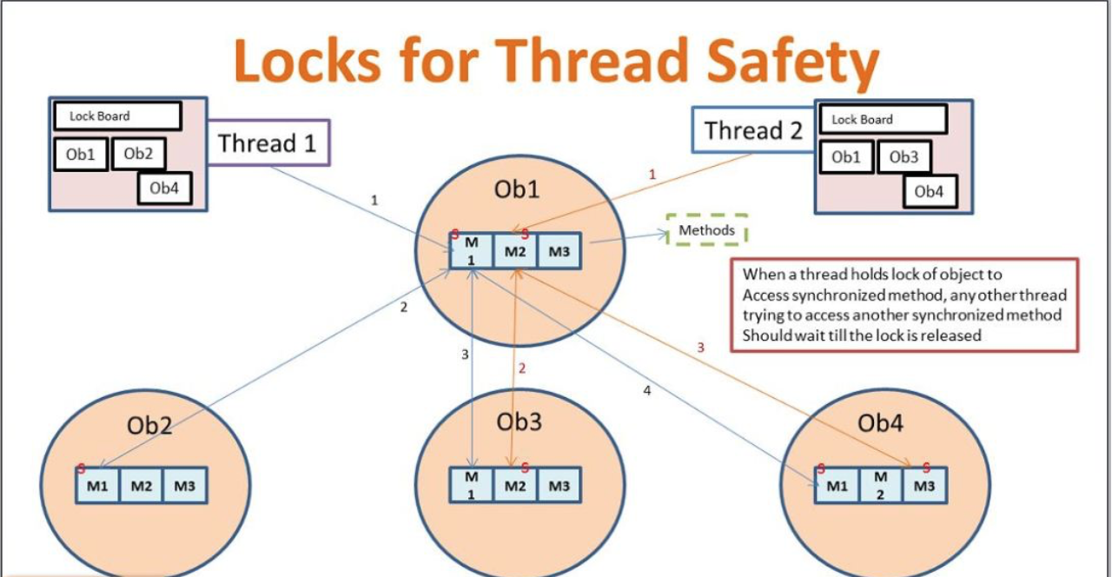

Figure 10 Locks for Thread Safety
- Disadvantages and Solutions

Dealing with multithreading in java not always come with advantages, there also some disadvantages which programmer need to face at. Using multithreading in Java, programmers need to find some strategies to solve those problems.

- The difficulty of writing code

When the programmer starts to write code in multithread, they are not like write several single programs and put them together, or merely extend/implement some code. Multithreading asks programmer able to put lots of threads together in same data, object and program. If programmers cannot figure it clearly, it easy to get lots of failures. Solving this problem, there are three essential strategies that programmer need to think about. First, synchronizing the critical part. Usually, users can only allow one thread to handle the most valuable part of the program, which makes the code easier to build and understand. But this strategy also will make the system performance go down, which means programmers should make it as small as you can, and only use it when you should. Secondly, the immutable object is best. Immutable objects only have one state since the project created, and is unable to change after that, which can keep the program stable, and less mess object use. Finally, warp all unsafe thread. This strategy is to use the safe thread wrap up the main class; it can help the program when it uses the main class from the third party or cannot update.

- Deadlock easy to happen.

In the multithread program, deadlock always appears when several threads work at same. The deadlock is when thread1 need to process object1 but need to wait thread2 responded. Thread2 want to process object2, but also wait thread1 responded. Then the deadlock happens likes [Figure 11]. To ignore the deadlock, the program should ensure two things. Each thread should only work with their data, and shouldn't share their data. Because if the thread just can use their data, they don’t need to wait or get other data from other thread, which means they will not wait for other thread because of the data sharing. And then, each thread should create their object and function rather than use object or function from other thread. The object and function sharing more worse than data sharing, because that means the object or function will do lots of travel between threads, and the code will look a mess.
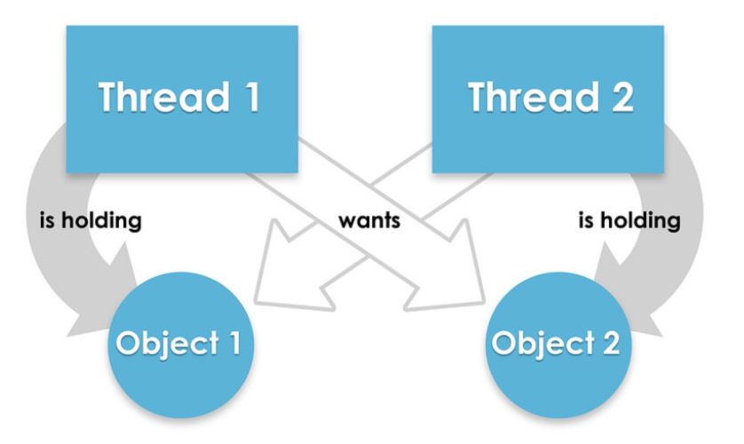

Figure 11 Multithreading Deadlock
- Difficulties of debugging and testing

In multithreaded java code, testing and debugging is more complex than single thread program. In testing part, defects are often timing-related and more difficult to reproduce. It is hard to test the exact part which engineering wants to test during multiple threads are running at the same time and same part. Similarly, in debugging part, when one piece of code gets error, all threads, which related to this part, will in trouble. The programmer needs to spend more time locating the location of the bug. The easiest way to solve that is using special tools to test the code. For example, a tool named Jconsole can show to the user how many threads are running, and the deadlock appears or not [Figure 12]. The programmer can check lots of useful information clearly through those tools. Also, add logs to each thread can help the programmer understand their code easier, even something goes wrong, the programmer can locate the bug faster through useful logs. Finally, when programming a multithreading java code, the programmer can set the number of threads as an input parameter in the main function. That’s means when the programmer does the testing or debugging; they can set the number of threads to run the code, it’s a flexible way to manage the multithread code in Java.
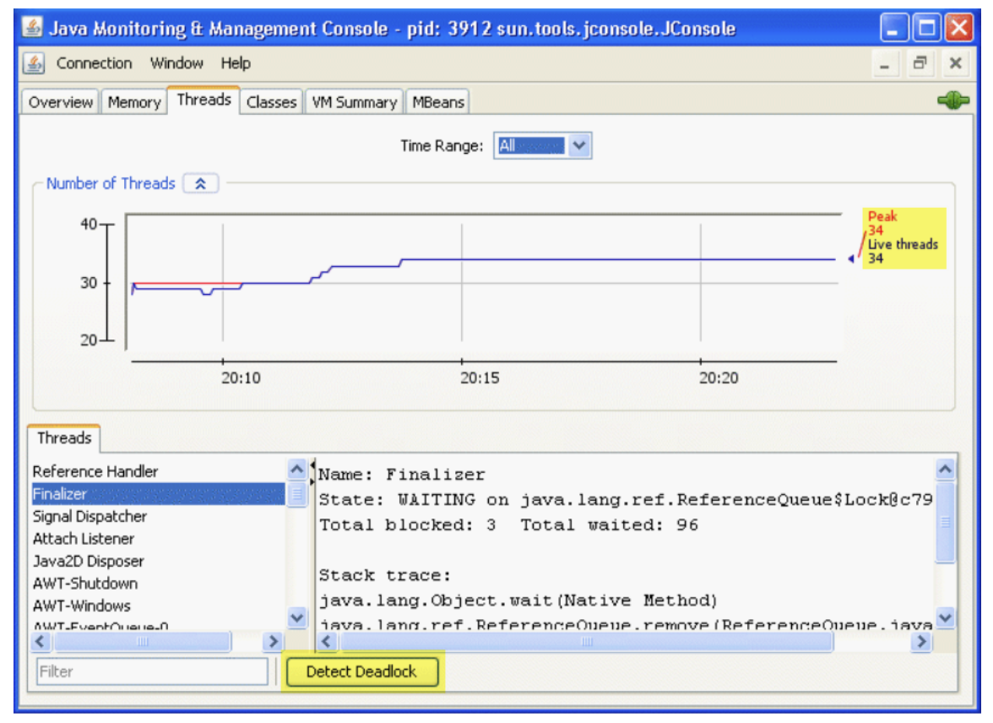

Figure 12 Jconsole Debugger

- Conclusion

All in all, multithreading in Java are popular coding style right now. Understanding what is multithread, are the way to learn multithreading in Java. This article gives two important information about multithread - the life cycle and thread scheduler in Java. To implement multithreading in Java, we usually use inherit the thread class and implement the runnable interface. Those two ways are most common implement for multithreading in Java. Also, modern applications are built in the way that the program can perform well while consuming fewer resources. Multithreading in Java is a right way that uses limited resource wisely. It effectively reduced the number of server’s request in multiple clients, improved performance, and concurrency and solved simultaneous access to various applications. But programming Java in multithreading way should also avoid some risks; programmer should have a bright design and firm control when they program the code and find the best way to test/debug their code effetely. As enhance of technology, there will be more area applied for multithread. And the solid foundation is the essential condition of learning multithreading in Java; the programmer should learn and practice more to determine the multithreading in Java.

Reference
[1] Why we use threads in Java: http://javarevisited.blogspot.ca/2017/03/why-we-use-threads-in-java.html
[2] What is multitasking: http://javasolutionsonline.blogspot.ca/2013/08/what-is-multitasking.html#.Wpdv3JPwa34

[3] Multithreading in Java: https://www.javatpoint.com/multithreading-in-java
[4] Java – Fork/Join, the work-stealing thread pool: https://www.logicbig.com/tutorials/core-java-tutorial/java-multi-threading/fork-and-join.html
[5] Lifecycle and States of a Thread in Java: https://www.geeksforgeeks.org/lifecycle-and-states-of-a-thread-in-java/
[6] Thread Safety and Code synchronization in Java: http://java9s.com/core-java/thread-safety-and-code-synchronization-in-java
[7] Dealing with disadvantages of multithreading: https://dzone.com/articles/deal-with-disadvantagesnbspof-multithreading
[8] Advantages and Disadvantages of using multithreading: http://www.careerride.com/NET-Th-advantages-disadvantages-of-multithreading.aspx
[9] Advantages and Disadvantages of multithreading system: http://www.itrelease.com/2017/12/advantages-disadvantages-multi-threading-systems/

